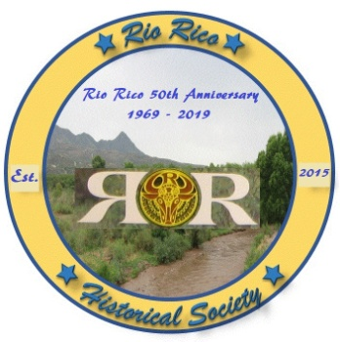
The Rio Rico Historical Society presents:

General Membership meeting FREE and open to the public, March 19, 2024 at 6pm at the Rio Rico Community Center, 391 Avenida Coatimundi, Rio Rico, Az.
Who Are the Sobaipuri O’odham ?
Guest Speakers:
- Tony Burrell, Cultural historian of Sobaipuri O’odham heritage and cultural specialist of the ethnographic team.
- David Tenario, Natural Resources Director & cultural specialist of the ethnographic team.
- Dr. Deni Seymour, an independent researcher and cultural specialist of the San Xavier del Wa:k ethnographic team. For four decades she has studied the Sobaipuri, some of the ancestors of today’s O’odham. Dr. Seymour is the discoverer of Coronado’s townsite of 1541 in Santa Cruz County.
Tony Burrell, David Tenario and Dr. Deni Seymour will present a talk on the ancestral people known as the Sobaipuri O’odham who occupied the Santa Cruz Valley and other valleys of southeastern Arizona. These riverside farmers occupied permanent settlements and greeted the Coronado expedition and ultimately routed them from the region. This presentation will characterize who they were.

